Recommended Junior Thespian Point Awards
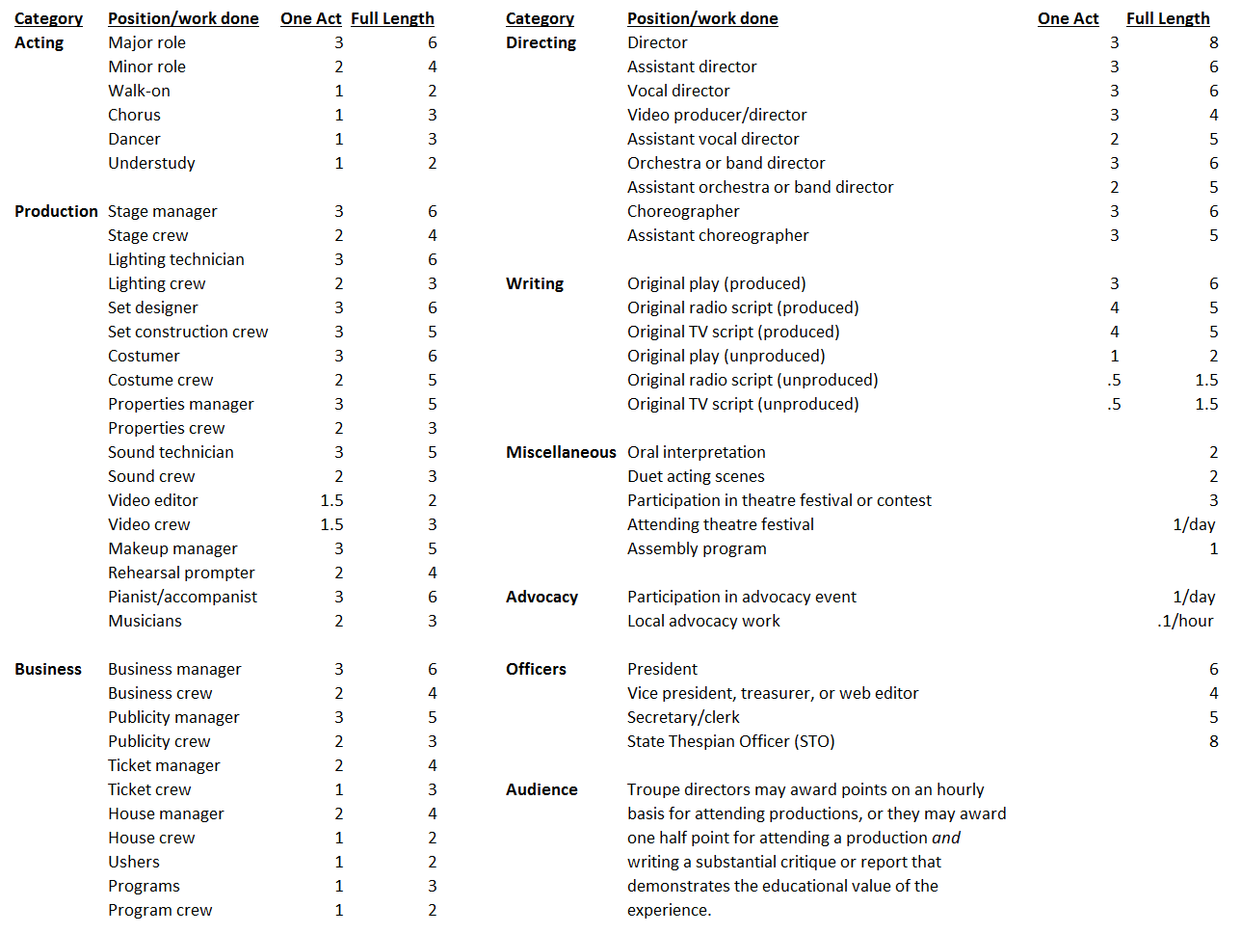
Junior Thespian Rating Summary
(see the Junior Thespian Troupe Handbook for details)
